Database name:ebilling;

* create database Ebilling;

create table stores(id int not null auto_increment primary key, name varchar(50) unique, address varchar(200));

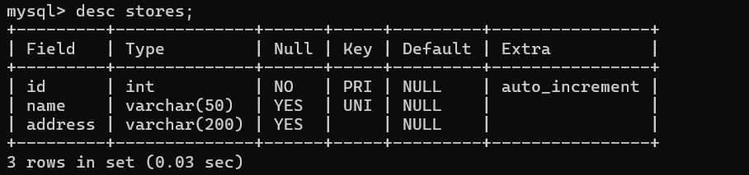

create table Employees(id varchar(50) primary key,name varchar(50), password varchar(200),email varchar(50) unique, phone varchar(50), designation varchar(20),store_name varchar(50) );

create table customers(id int auto_increment primary key,name varchar(50), password varchar(200),email varchar(50) unique, phone varchar(50) );

create table bills (bil_id int auto_increment primary key,customer varchar(50), customer_email varchar(50),store varchar(100),date_time varchar(20),total_amount decimal(20,2) default 0.0

);

* Adidas Shoe stores
* Vijaywada
* 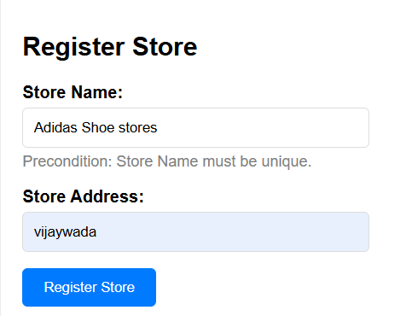
* Sign up:
* [john@gmail.com](mailto:john@gmail.com)
* Pass: [john@gmail.com](mailto:john@gmail.com)
* ODR<bill_id>
* 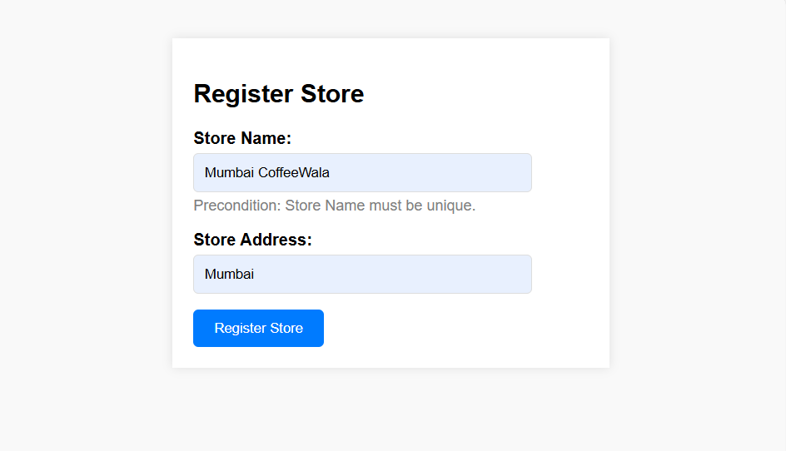
* 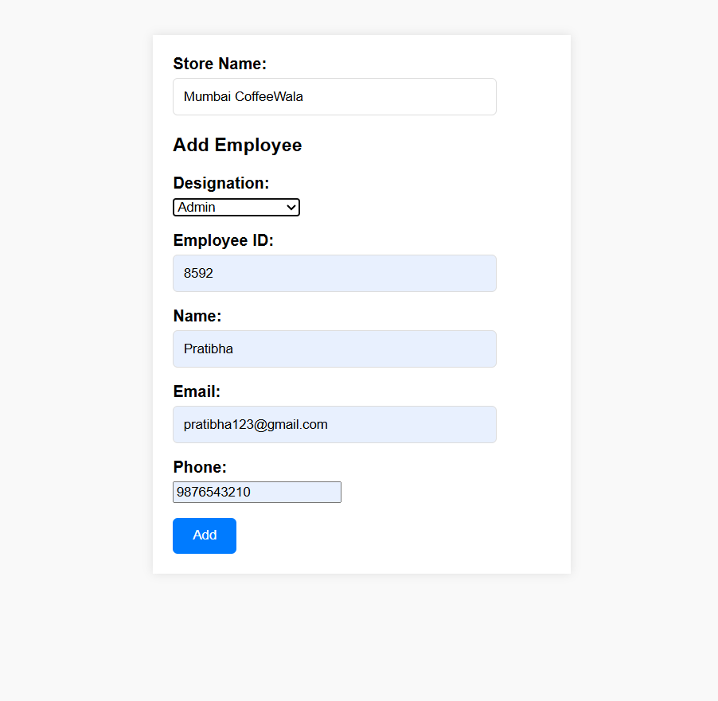
* 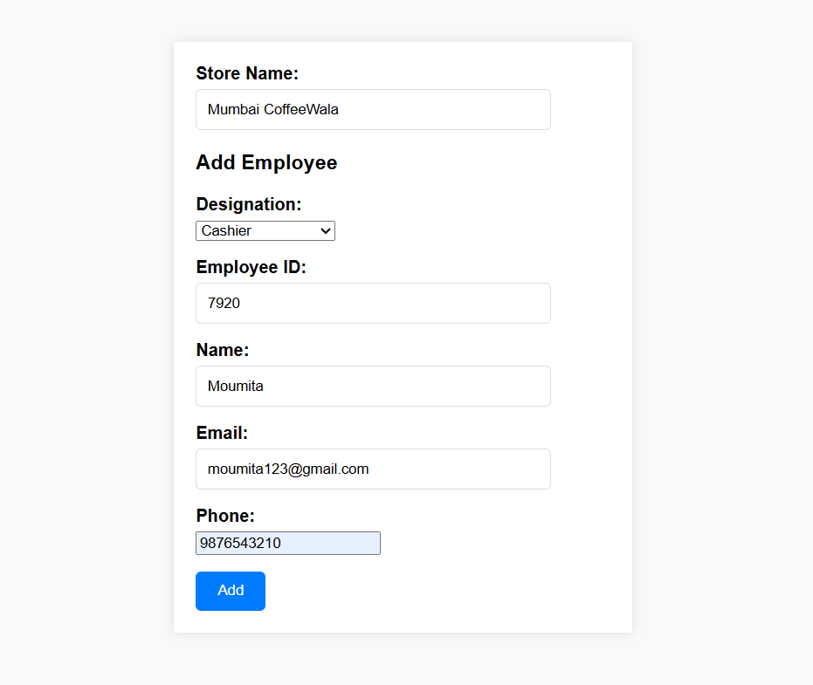
* By default password for all employee :email
* Username: email(unique)
* 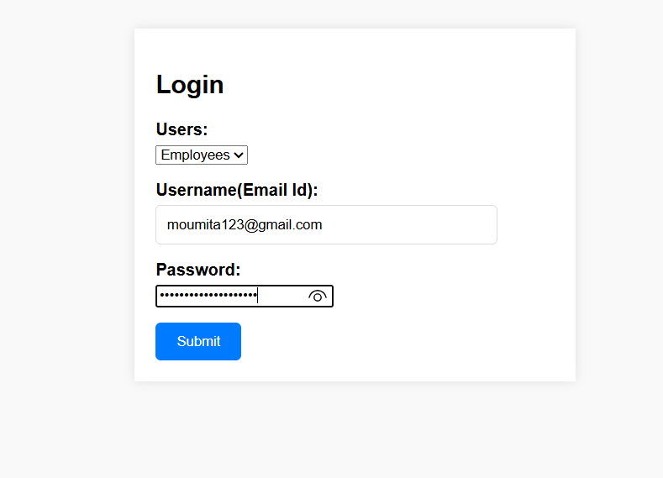
* 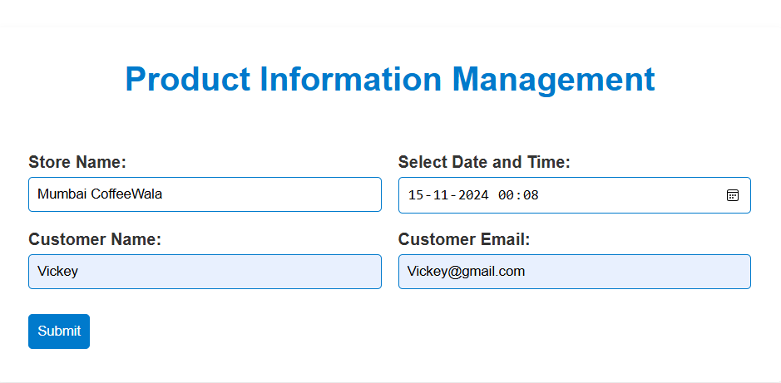
* 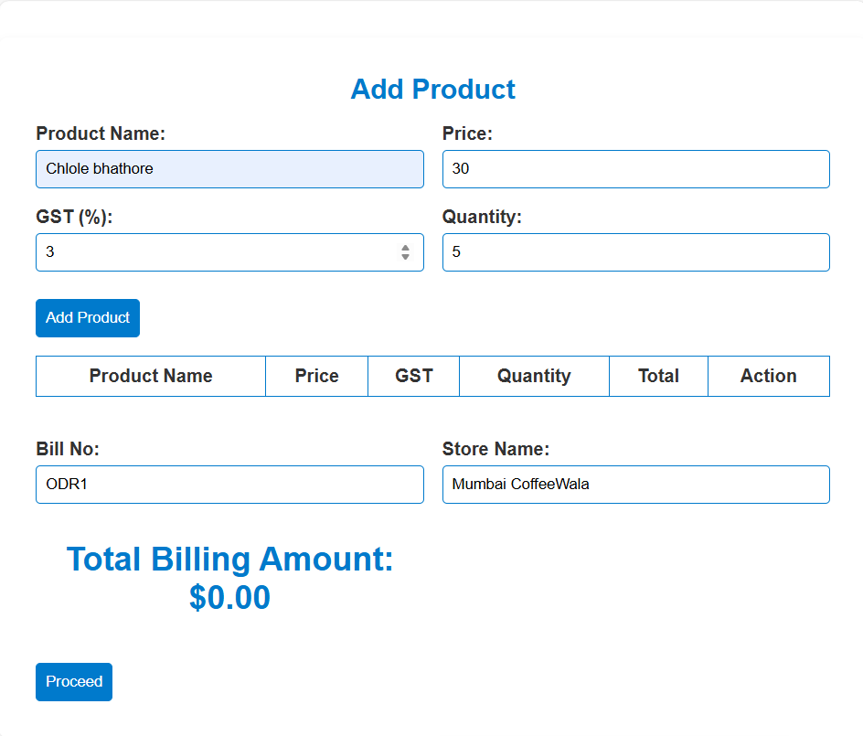
* 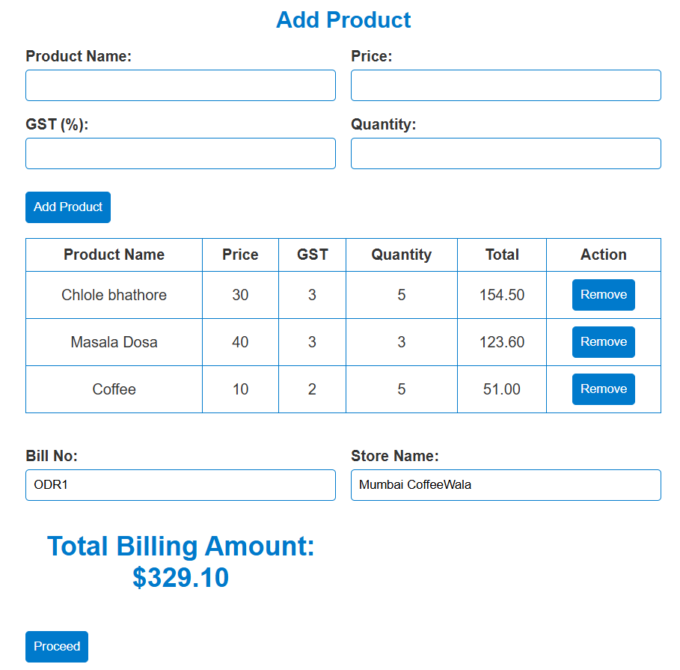
* 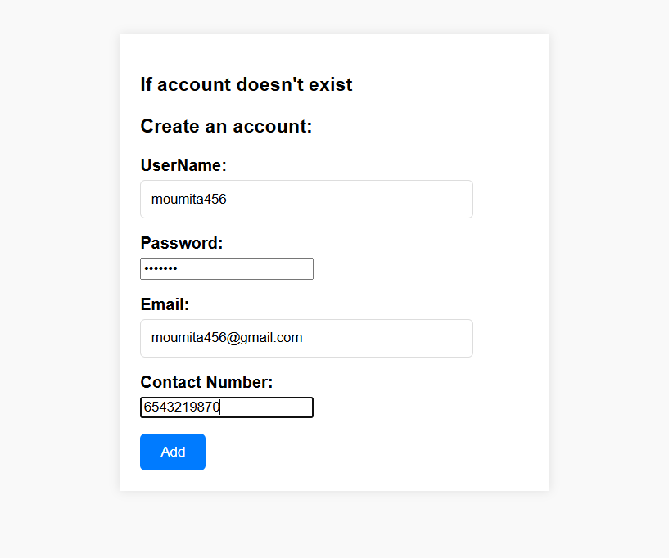
* Customer1 username: [moumita456@gmail.com](mailto:moumita456@gmail.com)
* Password:moumita
* Customer2 username: [Vickey@gmail.com](mailto:Vickey@gmail.com)
* Password:vickey

